- Challenge Name and Category: Redaction gone wrong (Forensics)
- Difficulty/Points: Medium
- Description: Now you DON’T see me. This report has some critical data in it, some of which have been redacted correctly, while some were not. Can you find an important key that was not redacted properly?
- Flag: picopicoCTF{C4n_Y0u_S33_m3_fully}
- Solution/Walkthrough: The redactions were not done properly. For this document you can highlight the redacted text and paste it into a word document or notepad. Some redactions are done so poorly the text can be viewed simply by clicking and dragging the mouse over it highlights it. Proper redaction on PDF files involves permanently removing sensitive content (text, images, and metadata) rather than simply covering it with black boxes or shapes. Using a dedicated redaction tool ensures that the underlying data is scrubbed, making it impossible for someone to copy, paste, or uncover the text
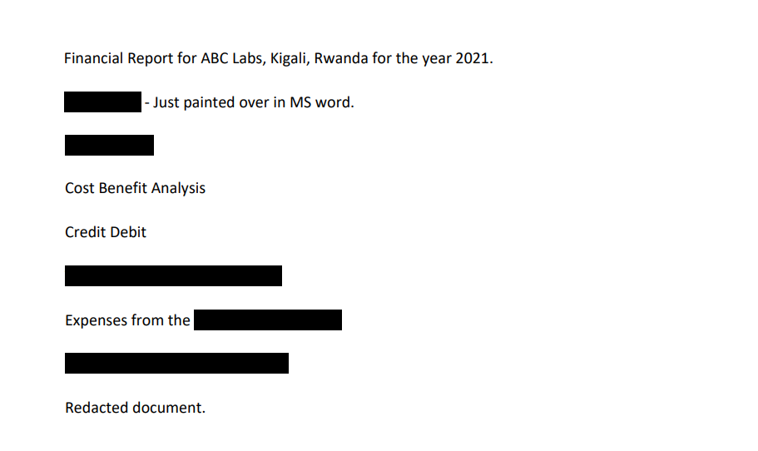
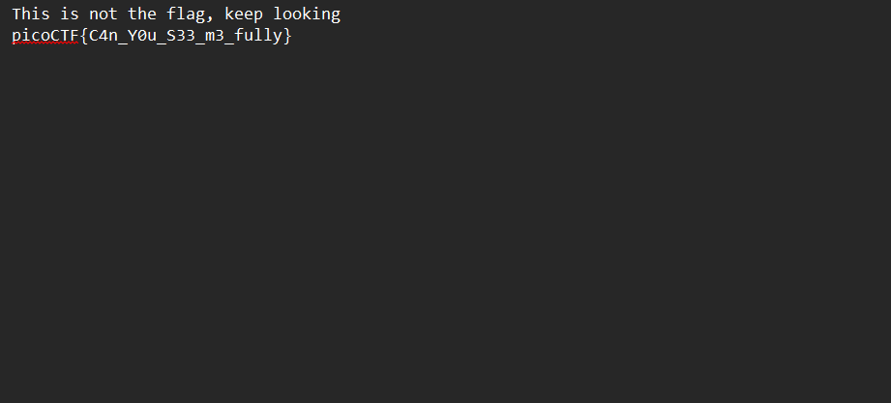
- Tools Used: Notepad
- Initial Reconnaissance: I was presented with a PDF file with redactions
- Hypothesis Formulation: All too often improper redactions are made. For example, unexperienced users may choose to create a shape, fill it black, and extend it over the sections that need to be redacted.
- What Worked vs. What Didn't: Copying and pasting the redactions was my first instinct and it happened to be what worked out for me in this instance.

